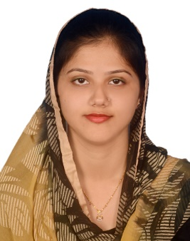**Israt Jahan**

168, North Kunipara, Shanti Niketon, Tejgaon I/A.

Contact no: 01627118450

E-mail: [mona.iqbal2015@gmail.com](mailto:mona.iqbal2015@gmail.com)

**Career Objective:**

Want to work with innovation and challenge. To work in an environment that provides generous opportunities for learning in the field of web development.

**Education:**

Southeast University

***Bachelor of Science, Computer Science and Engineering***

*2015-2020, CGPA:3.76*

Gazipur Govt. Mohila College

***Higher Secondary Certificate (Science), Under Dhaka Board***

*2013, CGPA :5*

Gazipur Cantonment Board Girls’ High School

***Secondary School Certificate (Science), Under Dhaka Board***

*2011, CGPA: 5*

**Technical Skills :**

* MicroSoft Office (Word, Excel, PowerPoint)
* Graphic Design with Adobe Photoshop & Illustrator.
* Front-End Developments with HTML5, CSS3, Bootstrap, JavaScript, jQuery, WordPress.
* Back-End Development: PHP, React. js

**Achievements :**

Have been in the merit list since the beginning.

**Research:**

* ECommerce Website using Angular.js, React.js, MongoDB

**Personal Data :**

* Father’s Name : Md.Mozaffor Hossain
* Mother’s Name :Ismat Ara
* Date of Birth :10/03/1995
* Religion : Islam
* Marital Status :Married

**References:**

1. Md. Emamul Hasan , CEO at Sampan Group of industries. Contact no: 01902234588
2. MD. Faruk Chowdhury, Seniors Executive (QS) Accounts, Employee code:17.1805, Bay Developments Ltd.

E-mail: faruk.c@baydevelopments.com